Contents

1. Machine Setup 2

3. Download 2

4. XAMPP Installation 3

5. SVN Installation 8

6. CouchDB Installation 11

7. Application Setup [To be done by mobifly team] 16

8. Test Cases [ChaiPoint Team] 17

# Machine Setup

1. Create new folder “Software” in D drive:
2. Make Sure Machine is connected to Internet

# Download

Below Mentioned Software (s) in “Software” Folder

1. XAMPP [FileName: xampp-win32-1.8.1-VC9-installer.exe]
   1. [URL] : <http://www.filehorse.com/download-xampp/11661/> And
   2. Click On DOWNLOAD Tab. After That download begin automatically and store in “
2. SVN [FileName : TortoiseSVN-1.8.8.25755-x32-svn-1.8.10.msi ]
   1. [URL] : <http://tortoisesvn.net/downloads.html> And
   2. Click On for 32-bit OS/64-bit OS Tab based on your Machine.
3. CouchDB [FileName : setup-couchdb-1.6.1_R16B02.exe ]
   1. [URL] : http://www.apache.org/dyn/closer.cgi?path=/couchdb/binary/win/1.6.1/setup-couchdb-1.6.1_R16B02.exe AND
   2. Click on [**http://apache.cs.utah.edu/couchdb/binary/win/1.6.1/setup-couchdb-1.6.1_R16B02.exe**](http://apache.cs.utah.edu/couchdb/binary/win/1.6.1/setup-couchdb-1.6.1_R16B02.exe) link. after that download begin automatically.

# XAMPP Installation

* + 1. Screenshot

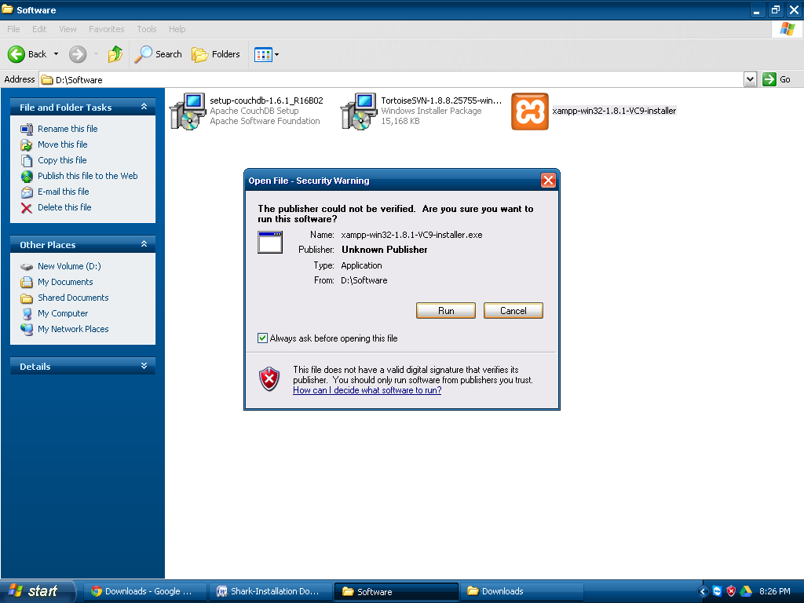

Figure

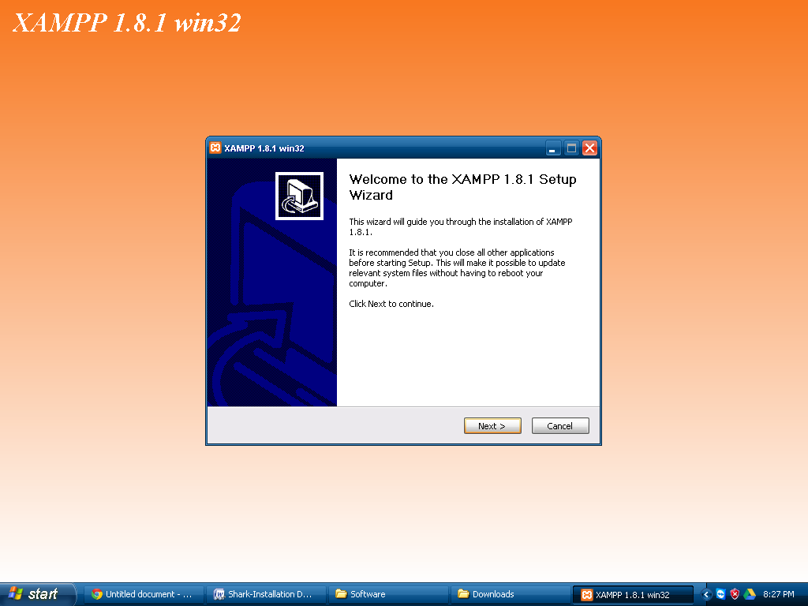

Figure

Change Drive to D:

# https://lh6.googleusercontent.com/0ZeN3ghXLn0zLxRtB9TZG1EIrJIMc5X8SnNqQVs6KZQ-pU0zkvE626vMec-M_g_IE-raM6V74ZdAMZXCasaie_gwdhvq4AzesafY2_eLErCFcX3cYmKSMuyVm65mRxFw-Q

Figure

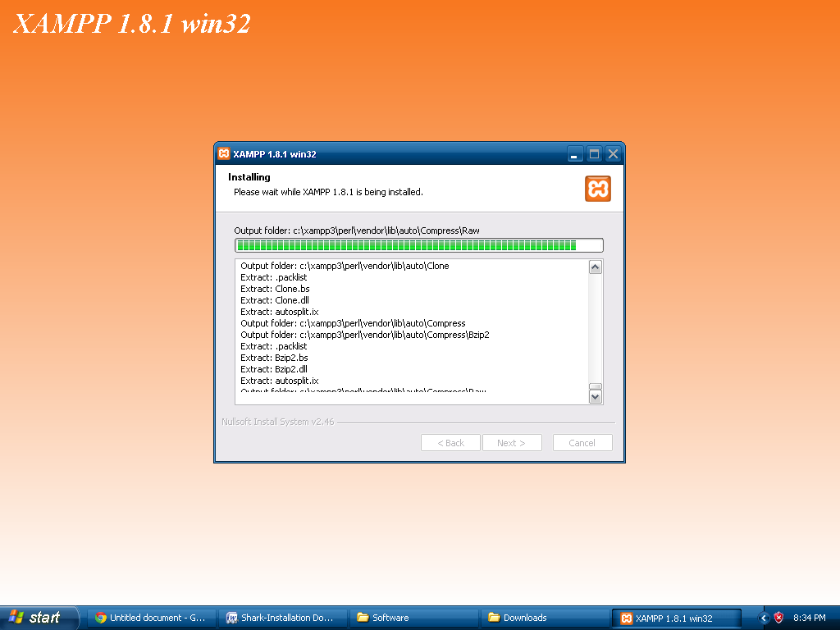

Figure

# https://lh4.googleusercontent.com/jUZM05nJKfLhcUgUrPVtsIBM1IXoVcAmYXEUnJPGgLZuQBWqxfDt-gB49XgS6pfgtBcykn0hpfS1w_MgcfeONSd5z1qM7pHWLc4ZDlqQ5KyXFZbpqB3evQ1aPeBXhDCBHw

Figure

# SVN Installation

1. Screenshot

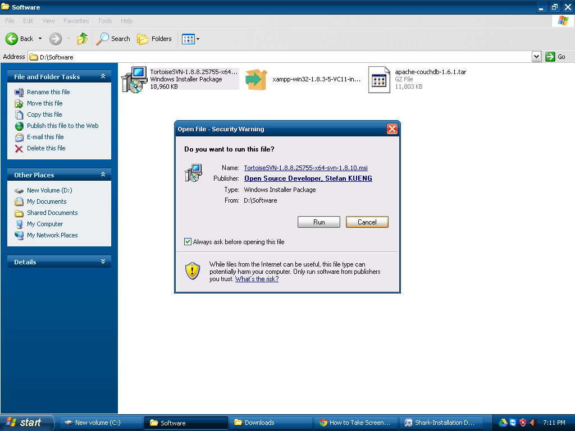

Figure

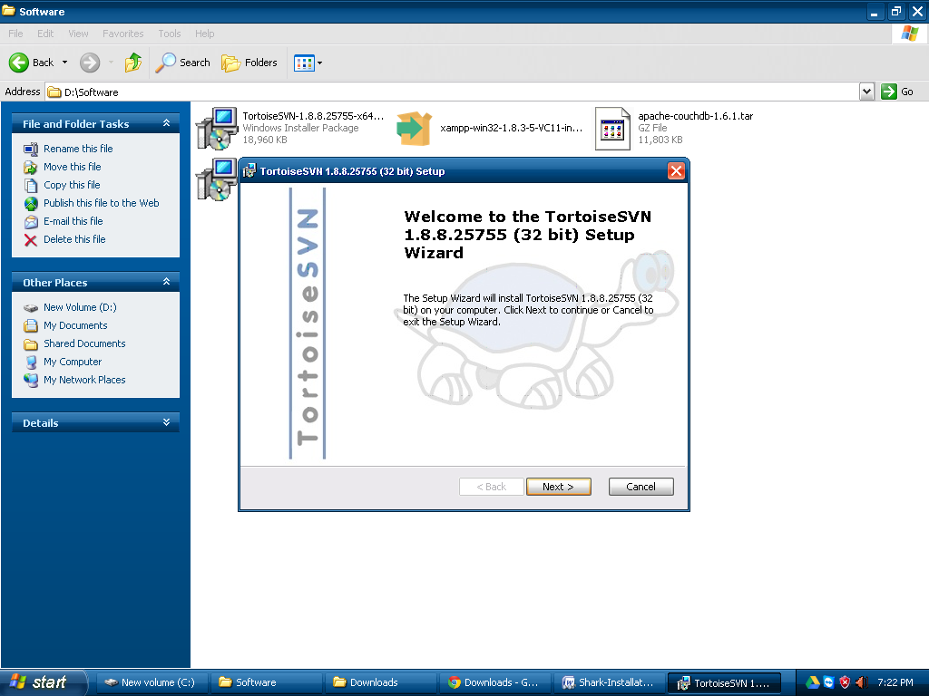

Figure

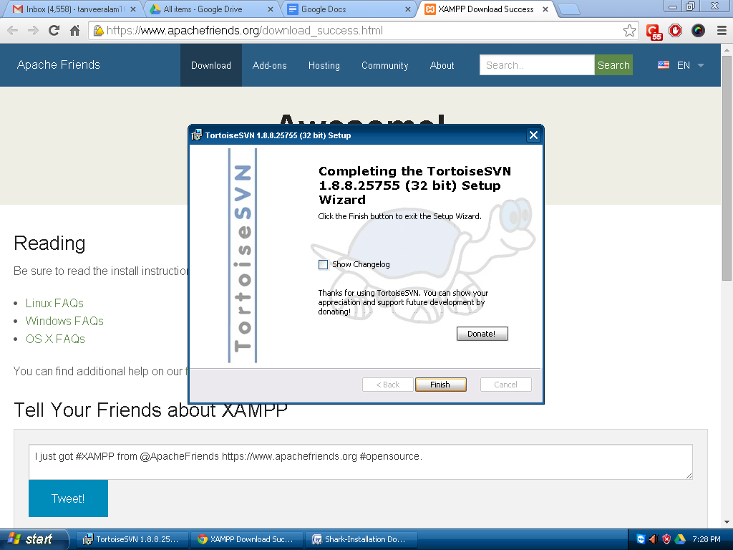

Figure

# CouchDB Installation

1. Screenshot

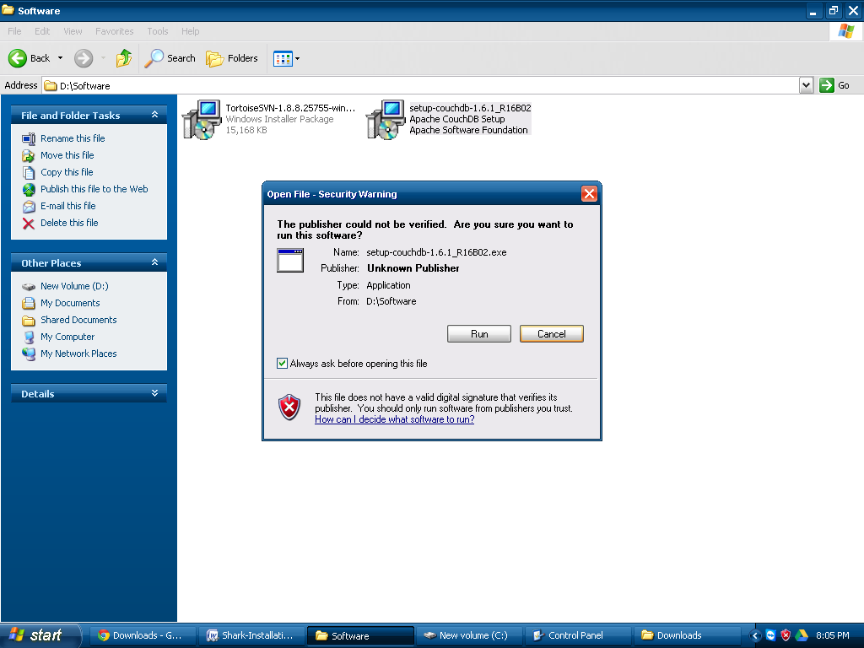

Figure

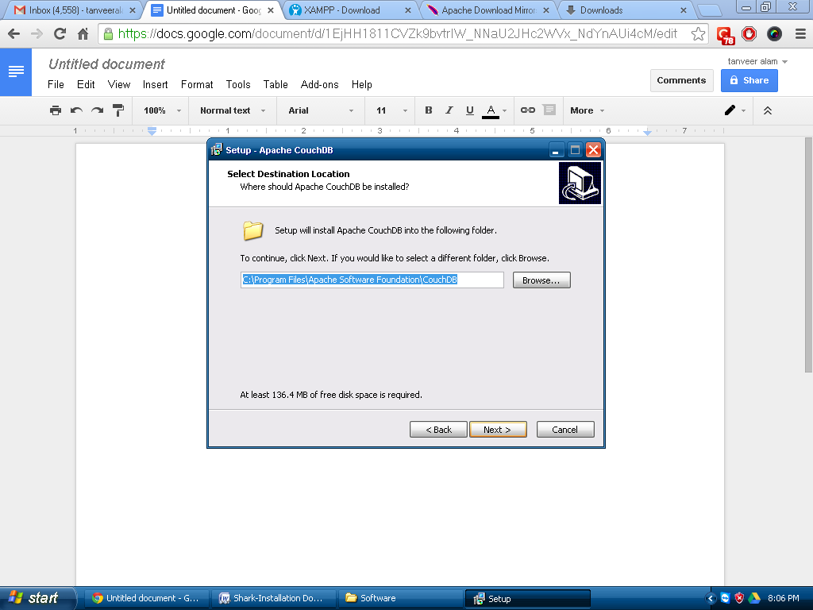

Figure

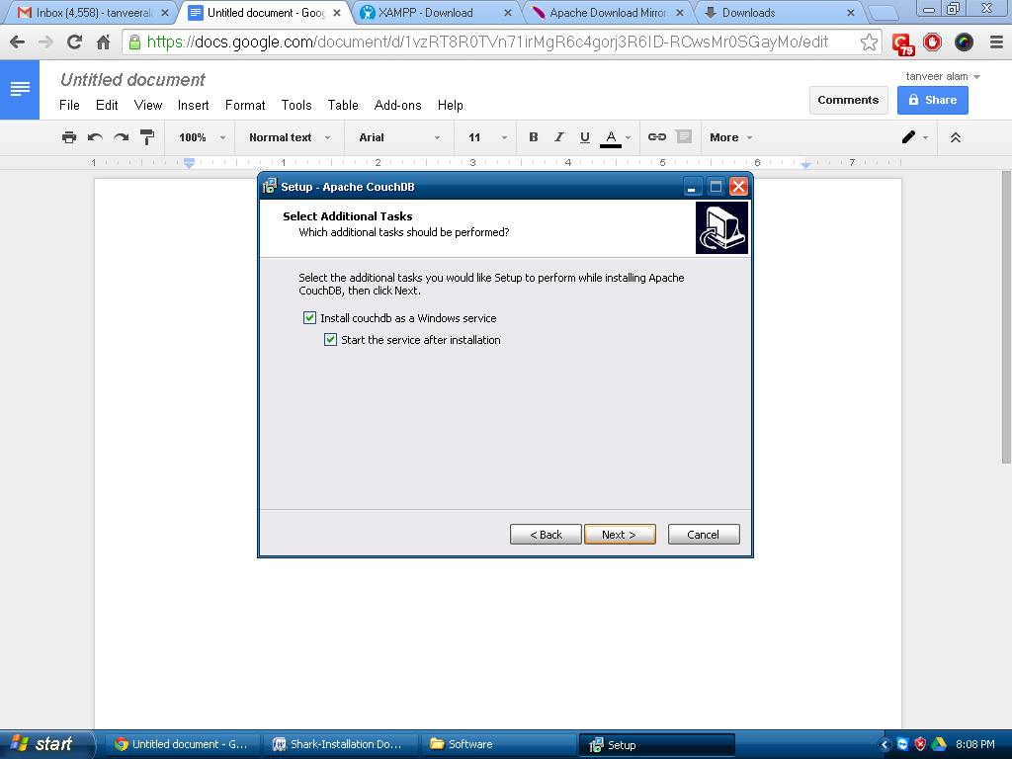

Figure

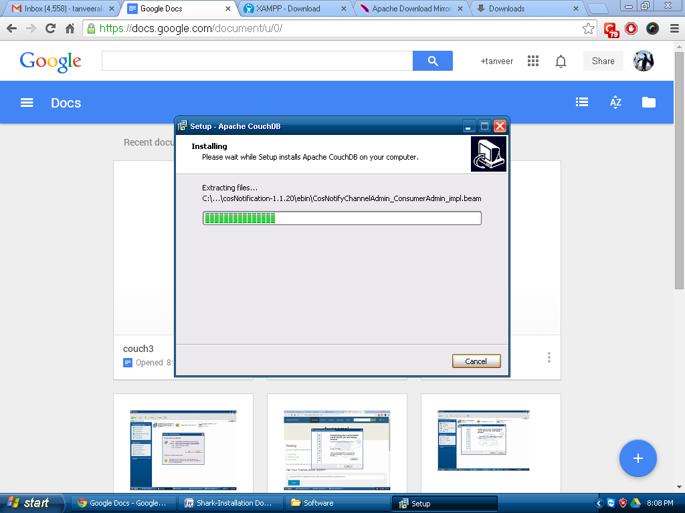

Figure

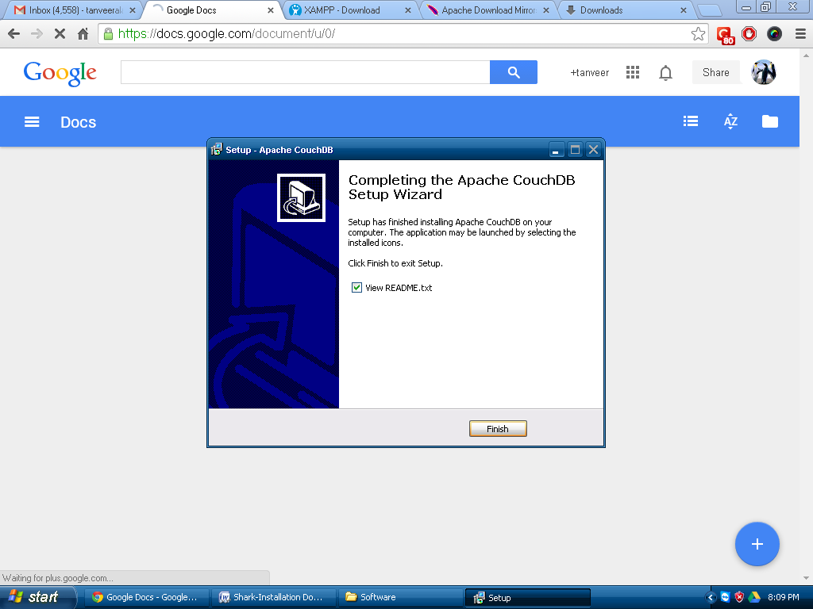

Figure

# Application Setup [To be done by mobifly team]

|  |  |
| --- | --- |
| **Task** | **SStatus** |
| o   Install NotePad++ |  |
| o   Change XAMPP Default Port (2020) |  |
| o   Setup XAMPP Service |  |
| o   Restart Computer |  |
| o   Test XAMPP and Couch DB Run Automatically after Machine Restart |  |
| o   Installation Verification for CouchDB |  |
| o   DB Creation (sharkpos) |  |
| o   Setup Username and Password (POS/POS) |  |
| o   RUN sharkpostsetup.bat [change location code and store code] |  |
| Verify Download from HO  Design Document  Store Data Verification  Staff Verification  For DELHI STORES (Total 67)  14 🡪 Design Document  1 🡪 Configuration Data Document  1 🡪 C@W Customer Data Document  1 🡪 Store Data Document  50 🡪 Staff Data Document  For BLR STORES (Total )  14 🡪 Design Document  1 🡪 Configuration Data Document  1 🡪 Retail Customer Data Document  1 🡪 Store Data Document |  |
| o   Create schedular for XAMPP Auto Start |  |
| **o   Create Bookmark of POS URL in Chrome Browser** |  |
| **o   Create Shortcut of sharksvnupdate, sharkdbdownload on Desktop** |  |
| **o   Create “Log Folder” on Desktop.** |  |
| o   Create Short Cut on Desktop for Log Folders (D:\xampp\apache\logs,D:\var\pos\log) |  |
| o   Clean Browser Cache |  |
| o   Open Login Screen |  |

# Batch File

# Test Cases [ChaiPoint Team]